1. **Report View :**

* Report view generally used to create the visualizations after loading and transforming the data as per our requirements.
* In the report view, we have four different sections

1. Page View 🡪 Here we can create the visualizations
2. Filter pane 🡪 Here we can filter our data as per our requirements
3. Visualization pane 🡪 Here we have different kinds of charts that we can select and play around with data. In this we have 3 more sub sections that are Fields, Format and Analytics where we can drag and drop the columns to the Fields and we can decorate our visualizations by using Format section.
4. Filed pane 🡪 Here we have the tables of data source that we have connected to. We can drag the columns and measures from here

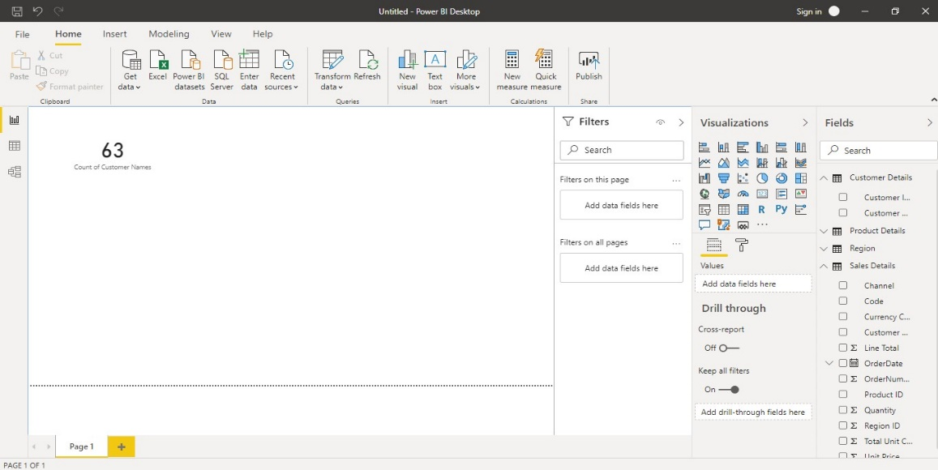

1. **Data View:**

In the Data view, we can see the entire table that we select. We can add new columns by doing calculations , We can filter data the at the column level. We can aggregate the data  
in the data view.

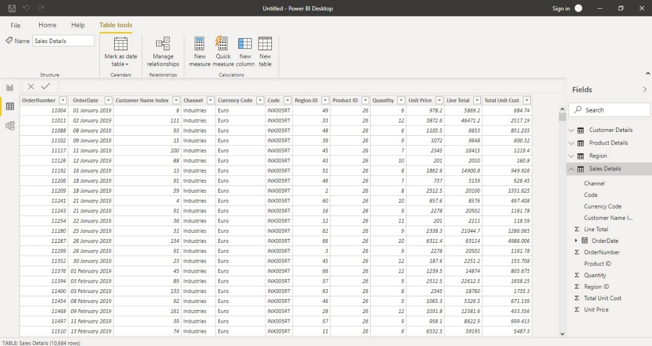

1. **Model View:**

In the Model view we can see all the tables od data source that have been connected. We can manage the relationship between different tables

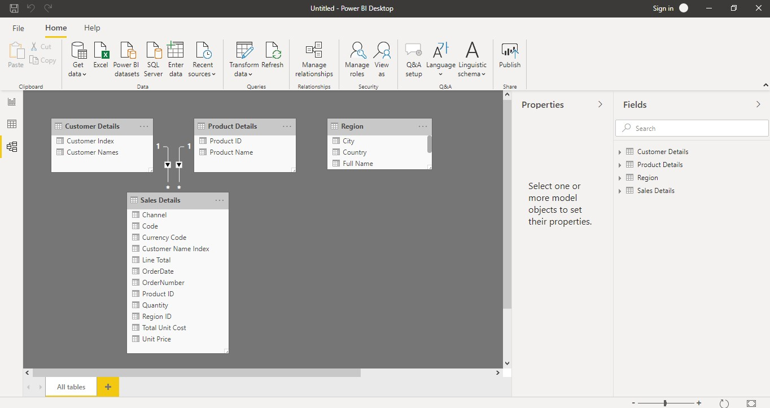

1. **Power Query Editor:**

This is where we can transform and prepare our data as per our requirements. We can do lot of things in power query editor. We can filter the data at column and we can remove the rows and columns that we do not require. Every change that has been done will be recorded in power query editor. We can move to the changes that have done. We can merge the data from different data sources. We ca play around with data in power query editor.

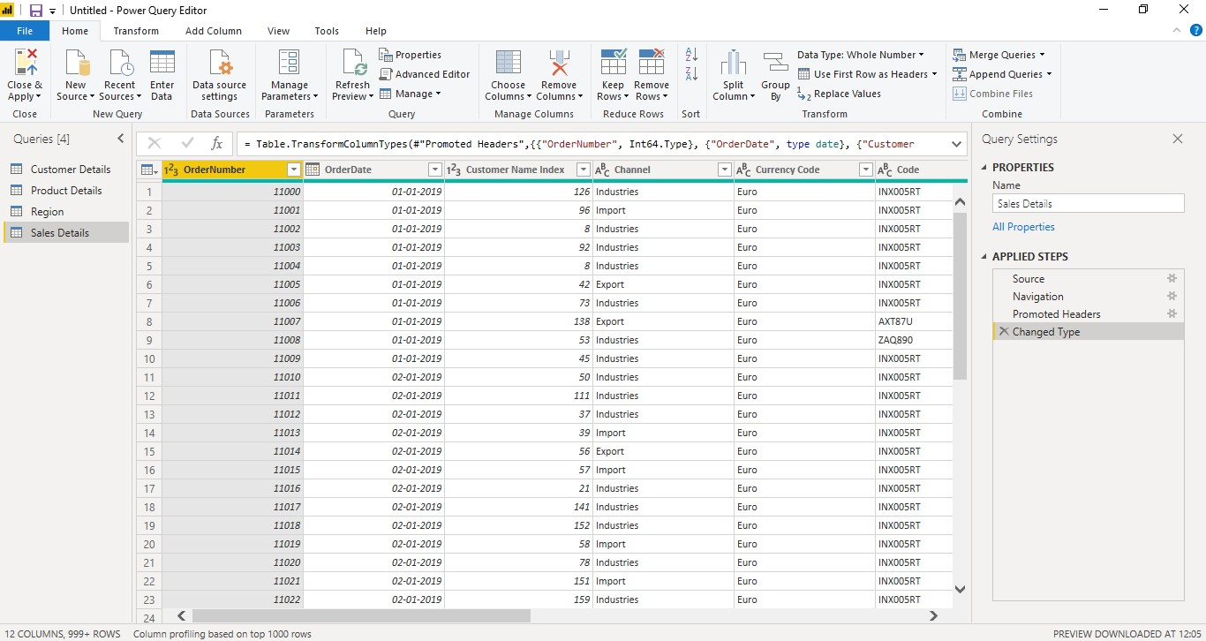

1. **Advanced Editor:**

Advance editor can perform lot of complex steps with any kind of data source. And advance editor can show the code related to changes that have done with power query editor.

We can edit the code as per our requirement

